Surface Water Hydrology
The purpose of this training module is to teach users how to use EPA-SWMM’s tools to edit a collection system network and develop hydrologic input data. You will learn how to use the SWMM–Runoff method of generating runoff from rainfall. Runoff will be simulated using SWMM hydrology. Finally, model results will be reviewed graphically and in tabular format.

EPA-SWMM simulates the rainfall, infiltration, evaporation and depression storage, for each subcatchment, and calculates the runoff to a collection node. A variety of hydrologic methods are available to generate runoff hydrographs.

Objectives
A collection network can be developed in the graphical interface using a variety of methods. In this example, users will learn how to utilize EPA-SWMM’s tools to layout a collection system network using the direct import of nodes, links and catchment polygons from shape files with GIS background images. You will learn how to:
Add and use a background image to verify object locations.
Edit nodes, links and catchments.
Use default settings for network objects.
Use EPA-SWMM’s graphical tools to calculate subcatchment areas.
Connect subcatchments to runoff nodes.
Assign design storms to subcatchments
Manage job control settings
Run the hydrologic analysis
Define the SWMM runoff parameters in a subcatchment
Use graphical tools to obtain data from catchment parameters
Review results

Data files to be used are:
Hydrology.inp
Background.bmp

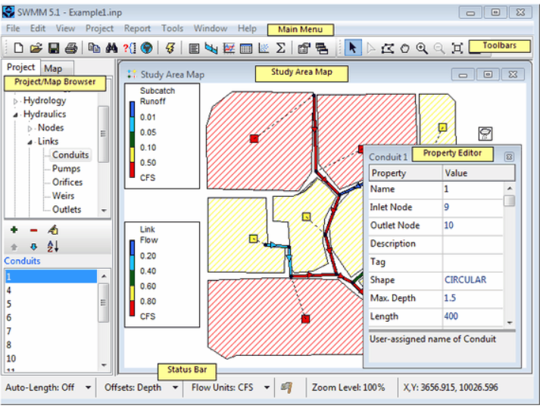
An EPA-SWMM model includes a series of input and output files. The main file is the .inp file that holds the data for the model and references other files needed. SWMM’s main window is shown below along with key elements of the window. The main menu is located across the top of the SWMM main window and includes a group of menus we will be using during the training. Toolbars provide shortcuts to commonly used operations. Project/Map browser provides access to all of the data in a project. The study area map provides a planar schematic diagram of the objects comprising the drainage system. The property editor is used to edit the properties of data objects that can appear on the Study rea Map. It is invoked when one of these objects is selected (either on the Map or in the Project Browser) and double-clicked or when the Project Browser's Edit button edit is clicked. The status bar appears at the bottom of SWMM’s Main Window and is divided into six sections. Please read the help file for additional information on each element.
Open EPA-SWMM and Review Existing Model Data
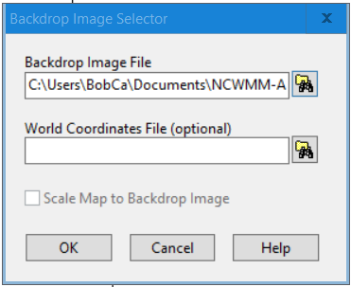
At the opening dialog, select either the Open an existing project button 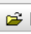 or the Open… under the File pull down menu. In the Windows Explorer, navigate to the Documents\Data\Austin\Hydrology folder and select the file Hydrology.inp. Select Backdrop under the View pull down menu. Then select Load… and using the Windows Explorer , select Background.bmp. Then click the OK button to add the background image to the model. The model is shown on the following page.

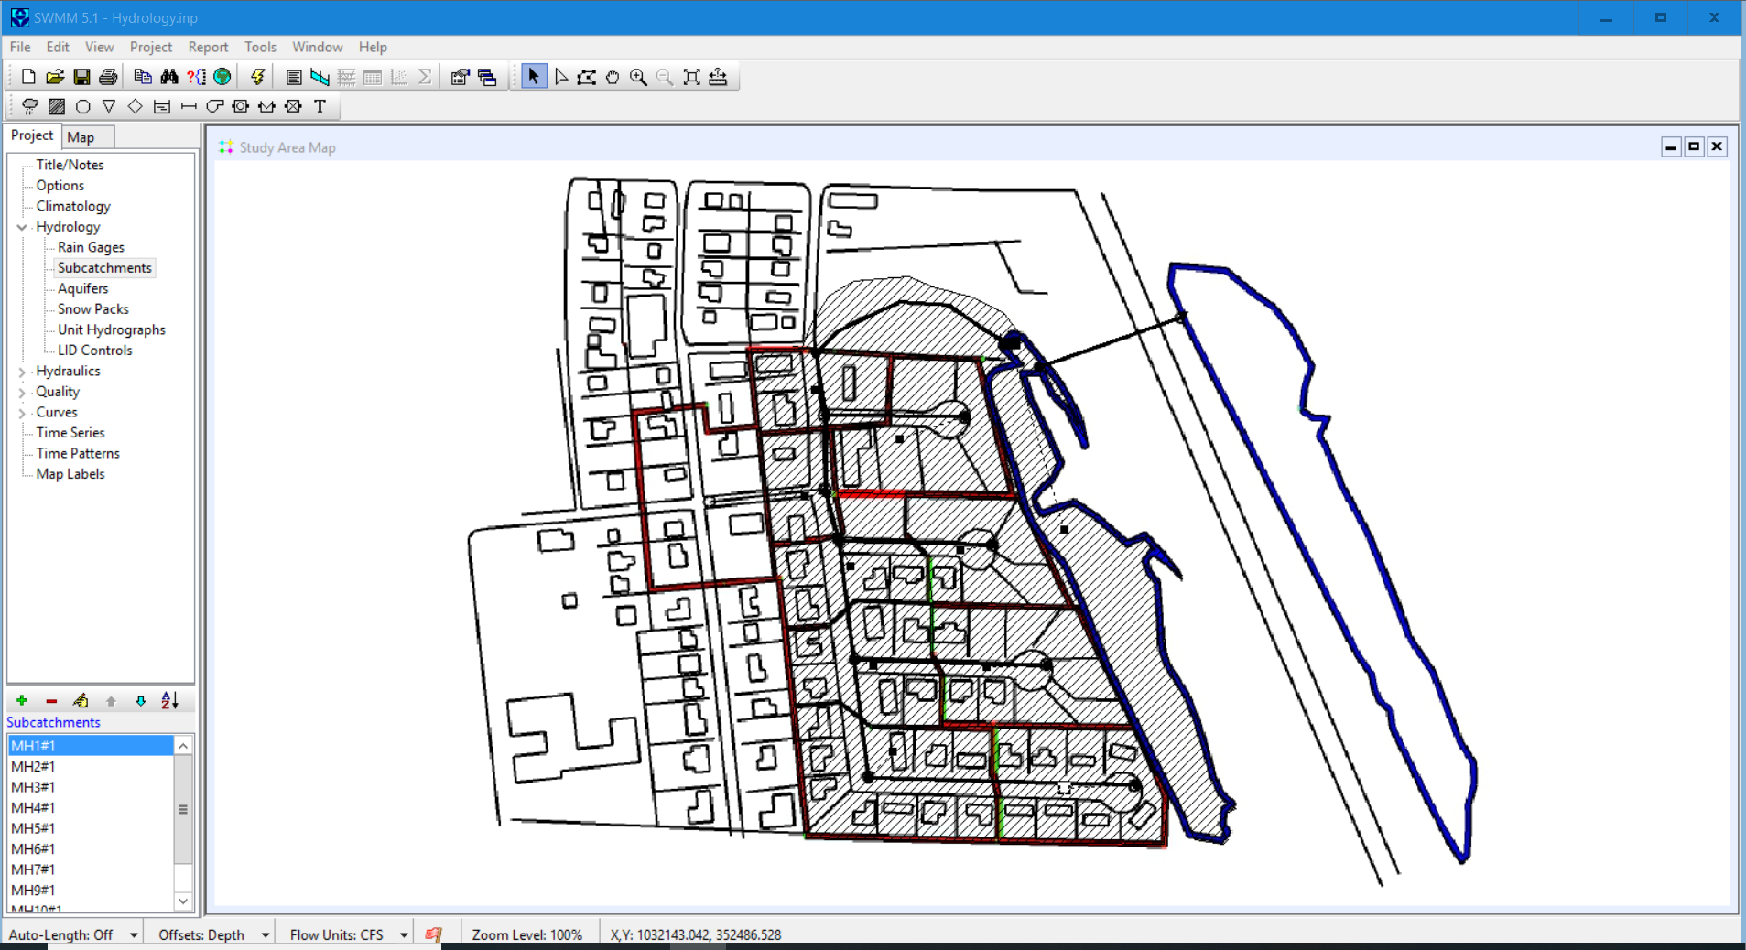
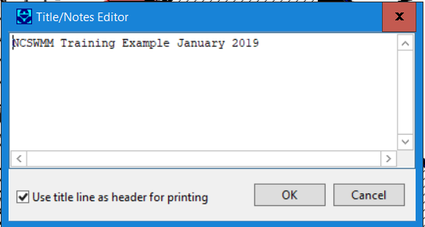
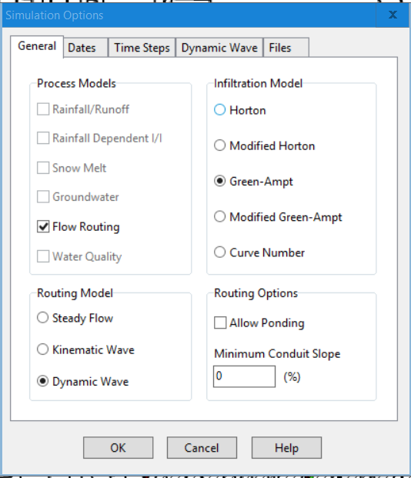
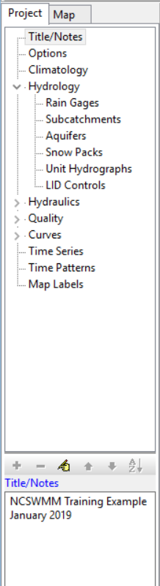
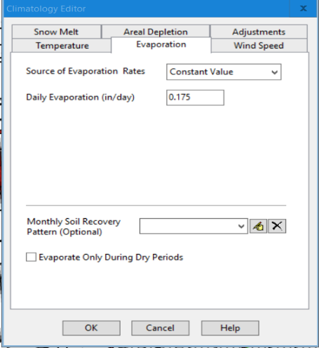
The next step is to review the data in the model. An overview of the data is available Select the Project pull-down and choose Summary. This provides the project summary including the number of subcatchments, nodes, and links. Select the Project pull-down again and then select Details. This shows the user all of the data within the model by data category. However, the user can not edit the data. In the Project/Map Browser, the user can see and edit the data by category. By selecting the edit button , the user can edit the data in the window to the left. The next step is to review the general data in the model by walking through the Options and Climatology data. By selecting the Options list, a series of simulation options are provided as shown to the right. We will go through each of the Options. Only the Flow routing module is active. Before we can run the model, a rain gage and rainfall data need to be added to the model. The routing model is the Dynamic Wave and we will be using the SCS Curve Number instead of the Green-Ampt model. The dates are set to September 2018 and the time steps are good for starting this study. Review the Dynamic Wave options. The Climatology data is also provided as shown to the right. The only data we will be using in this example is the Daily Evaporation Rate. From the Texas Water Development Board, the average daily evaporation rate for the last four years during September is 0.175 in/day. In more advanced examples, additional data such as wind speed and temperature are required.
Adding Rain Gage and Rainfall Data
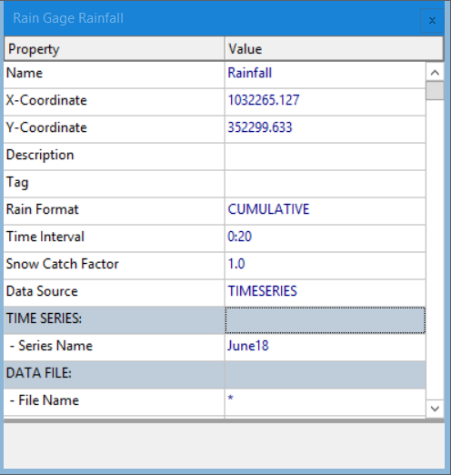
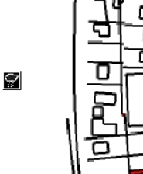
In the Project/Map Browser select Hydrology, Rain Gages and then the green plus button. Then click on the drawing to add the rain gauge as shown to the left. Then click on the edit object button to add the rainfall data. Add the data to the right including the Name, Rain Format, Time Interval, Data Sources and Series Name. Then double click on June18 and type in Time Series Name (June18) and Description (Rainfall). Open the rainfall.xlsx file and copy and paste the data from the sheet June 18 into the Time and Valve columns. Then click on the View button to see the rainfall data.
Run the Model and Review Results

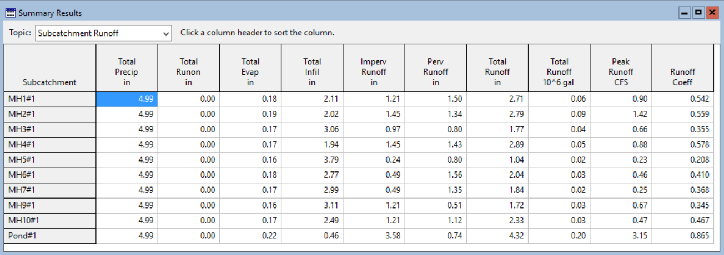
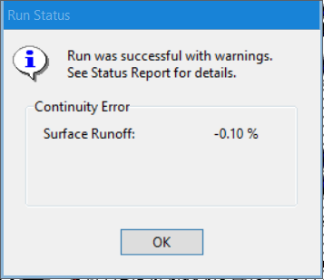
Select Options in the Project/Map Browser and turn off the Flow Routing for now. This way we will only run Hydrology and will generate runoff from the subcatchments. To run the software, we can select the lightning bolt or select Project in the Main Menu and Run Simulation. A Run Status box will appear with information about the run. In this case, we see that the run was successful with a Surface Runoff Continuity Error of -0.10 %. Additional information is provided in the Project Main Menu under Report and Status Report. A summary of hydrologic data is shown in the Summary Results shown below.
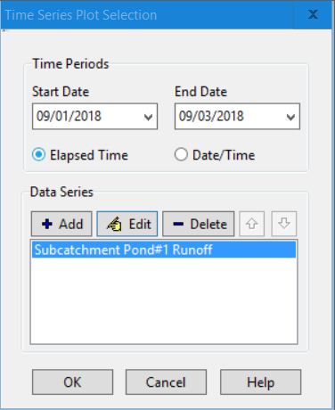
Users can also look at graphs of individual or multiple subcatchments by selecting the Create a time series button or the Graph Time Series under the Report in the Project Main Menu. Select the Pond Subcatchment and click on the time series button and the Time Sewers Plot Selection Dialog Box will appear as shown to the right. The user can chose to display the Pond or can add additional subcatchments. Let’s add subcatchment MH5#1 by clicking on the +Add button and selecting MH#5#1 and then select the Accept button. Both the Pond and the MH5 runoff graphs will be shown.
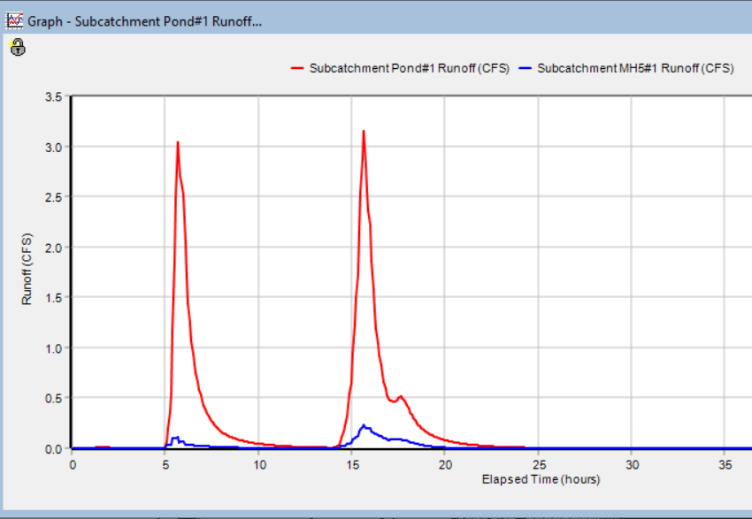
SWMM can also calculate statistics and show scatterplots. These will be discussed in an advanced example.

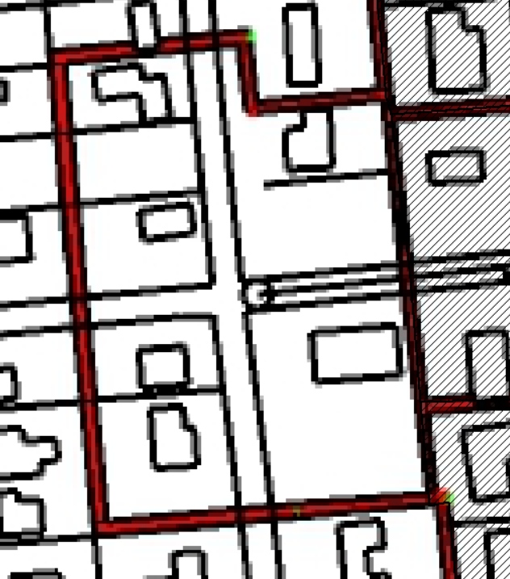
Editing Subcatchments in Model
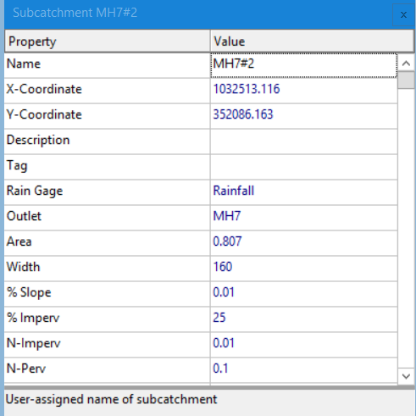
During the review of this model, it was noted that a subcatchment was not included. We can see the missing catchment in the background image shown to the right. We will add this subcatchment to the model by using the zoom in tool in the toolbar. Then select the Subcatchments in the project/map browser and click on the + button. We will trace the outline of the new subcatchment. Then select the Edit Object button and type in the data shown to the left. Specificlly the Name, Rain Gage, Outlet, Area width, % slope and % impervious. Then scroll down to Infilitration Data and click on the … to add a curve number of 75. Close the dialog box and save the model as Hydrology_B.inp.
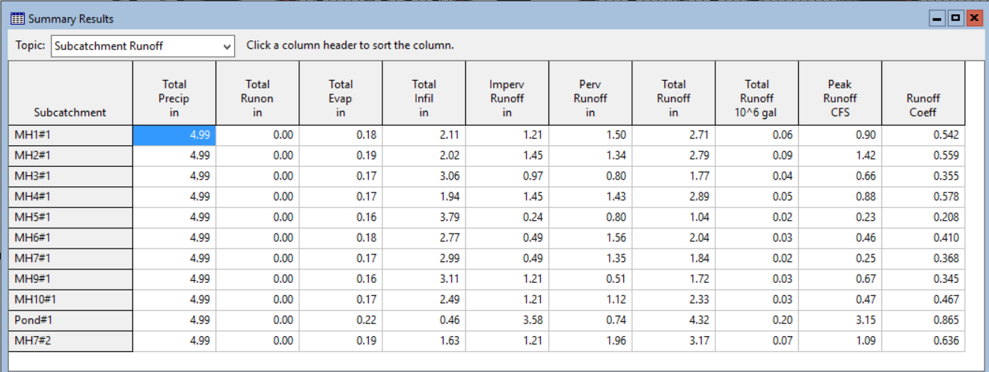
Now we will re-run the model and compare the results from our first run. A summary of hydrologic data is shown in the Summary Results shown below. Note that all the numbers are the same plus the additional subcatchment.

Rainfall Data for a SCS Runoff Distribution
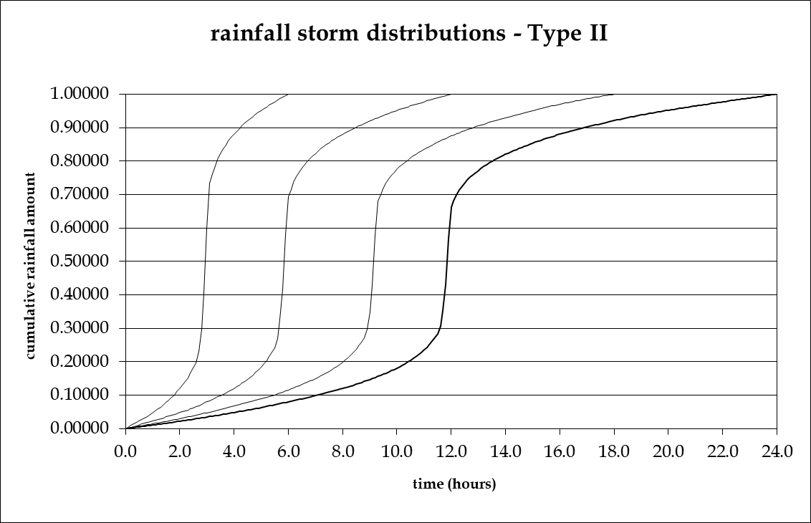
Currently, EPA-SWMM does not include the actual SCS runoff procedure. However, we can use the SCS Rainfall Distribution with the SWMM Runoff calculation and the SCS curve number for infiltration to determine the an approximate SCS rainfall to runoff relationship. The SCS rainfall distributions are: Type 1, Type 1A, Type 2 and Type 3. Each distribution has a 6-hour, 12-hour, 18-hour and 24-hour distribution. The Type 2 distribution for all durations are as shown to the left. The 24-hour distribution are typically used. Open the EPA-SWMM file titled: SCS_Rainfall.inp. Each of the rain gages have a total of 5 inches of rain. Open each of the Rain Gages and review the rainfall data by double clicking on the Series Name and then on the View Button. Do the above for all four Rain Gages. Note the differences in four distributions shown on the next page. Then run the model by clicking on the lighting bolt. Note that the surface runoff continuity was 0%. Click on the Create a Time Series plot and add all four subcatchments to create a graph showing all four of the SCS distribution.
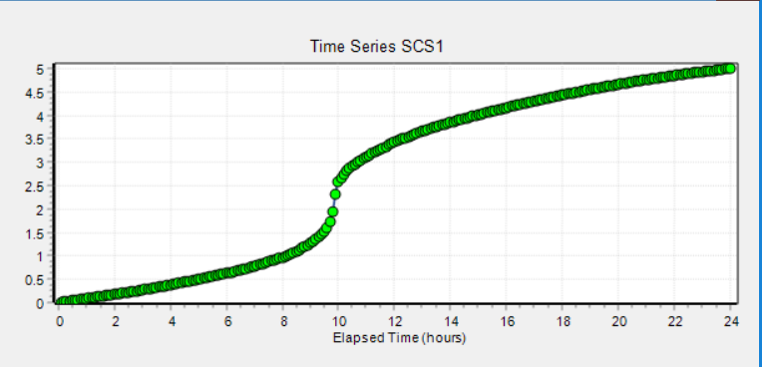
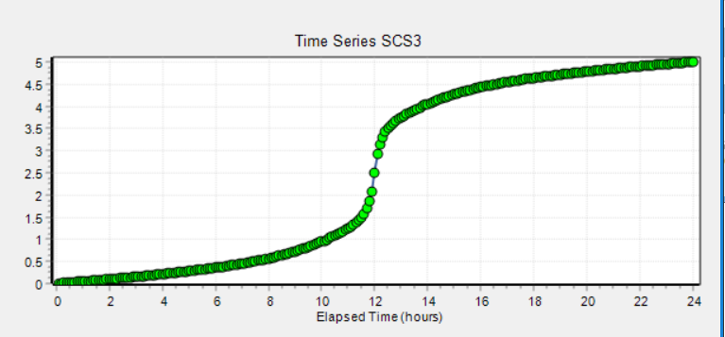
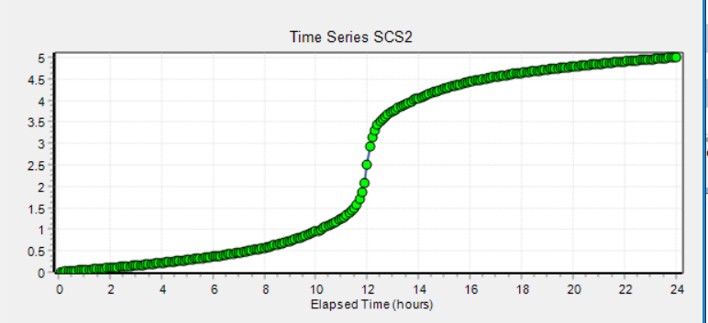
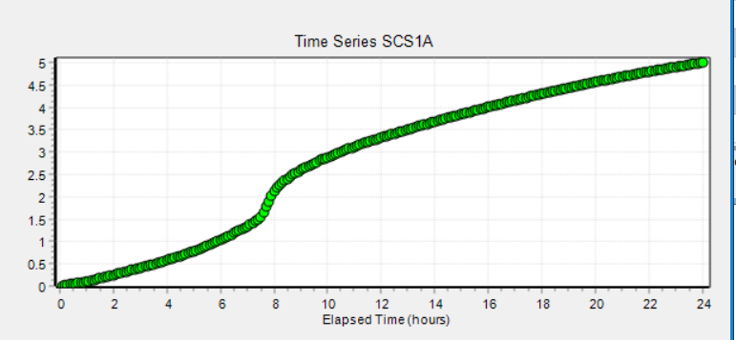
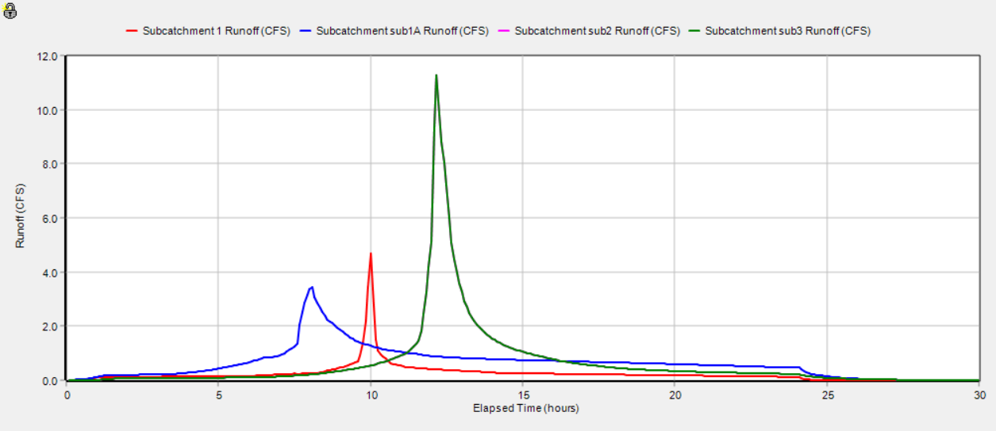
The plot below shows the four SCS distributions. Note the differences between the distributions and that the difference bteween the type 2 and type 3 is very difficult to see.

Questions
Considering the first file (Hydrology.inp) we created:
How many subcatchments are in the model? _________
What was the date and time that the Analysis Started? ________
Is there a limit of subcatchments in EPA-SWMM that are allowed to attach to a node? Yes or No

